|  |  |
| --- | --- |
|  | [www.metaopensciences.com/index.php/BJBS](http://www.britishopensciences.com/index.php/BJBS) ISSN online: 0000-0000 |
| **British Journal of Business Sciences** |

*Article*

**Title of Study Title of Study Title of Study Title of Study Title of Study Title of Study Title of Study (Font: Palatino Linotype, Size: 14, bold)**

Author Full Name1*, Author Full Name2 and Author Full Name3 (Font: Palatino Linotype, Size: 10)

1Author’s affiliation include department, university, city, country, ORCID and Email (Font: Palatino Linotype, Size: 8)

2Author’s affiliation include department, university, city, country, ORCID and Email (Font: Palatino Linotype, Size: 8)

3Author’s affiliation include department, university, city, country, ORCID and Email (Font: Palatino Linotype, Size: 8)

*Corresponding author: (Font: Palatino Linotype, Size: 8)



**Abstract** (Font: Palatino Linotype, Size: 10, bold)

The abstract is a critical part of a research paper, providing readers with a concise summary of the entire study. Authors should write the abstract in a single paragraph, covering the purpose of the research, the methodology used, the key findings, and the main conclusion or implications. It should begin by stating the research problem or objective clearly, followed by a brief description of the methods used to conduct the study. The abstract should then summarize the principal results, highlighting any significant data or trends identified. Finally, it should conclude with a statement on the importance of the findings, their contribution to existing knowledge, or potential practical applications. Authors must ensure that the abstract is clear, objective, and informative without including citations, abbreviations, or references to tables and figures. The word count for the abstract should not exceed 250 words. (Font: Palatino Linotype, Size: 10)

**Keywords:** keyword1; keyword2; keyword3; keyword4; keyword5 (Font: Palatino Linotype, Size: 10)

Received 7 May 2025; Revised: 10 July 2025; Accepted: 11 July 2025; Published: 13 July 2025 (Exact date will be added later)

Citation: John, G., & Peter, F. (2025). Study on business and management in the manufacturing sector. *British Journal of Business Sciences*, 1(1), 1-20. https://doi.org/10.3110/BJBS123456

­

Copyright: © 2025 by the authors. Published by Meta Open Sciences. This article is an open access article distributed under the terms and conditions of the Creative Commons Attribution (CC BY) license (https://creativecommons.org/licenses/by/4.0/).

**1. Introduction** (Font: Palatino Linotype, Size: 10, bold)

The introduction should provide a clear background and context for the study, explaining why the research topic is important. Authors should begin by discussing the broader area or problem, highlighting existing literature and identifying any gaps or unresolved issues. This creates a logical flow towards the specific research problem or question addressed in the paper. Clearly state the aims or objectives of the study and, if applicable, include the hypotheses tested.

The introduction should demonstrate the significance of the research, its potential contribution to theory or practice, and its relevance to the journal’s audience. Avoid excessive review of literature; only include key references that build towards the research gap. The introduction should be written concisely, maintaining a professional academic tone, and should engage readers to understand the purpose and value of the research presented. (Font: Palatino Linotype, Size: 10)

**2. Literature Review** (Font: Palatino Linotype, Size: 10, bold)

The literature review should provide a comprehensive overview of existing studies relevant to the research topic. Authors should summarize, analyze, and critically evaluate prior research, highlighting key theories, models, and findings related to the study area. The review should identify gaps, inconsistencies, or limitations in the current literature that justify the need for the present research.

It is important to organize the literature logically, either thematically or chronologically, ensuring a clear flow of ideas. Authors should avoid merely listing studies; instead, integrate and synthesize information to build a strong foundation for their research objectives. The literature review should conclude with a clear statement of how the current study addresses identified gaps and contributes to existing knowledge. Maintain an academic, objective, and critical tone, citing all sources appropriately using APA 7th edition style. (Font: Palatino Linotype, Size: 10)

2.1. Variable and Hypotheses (Font: Palatino Linotype, Size: 10)

In this section, authors should define and describe each key variable examined in the study, explaining its conceptual meaning and relevance to the research. Provide clear definitions supported by literature and explain how each variable is measured or operationalized in the study. This helps readers understand the scope and focus of the research. Additionally, authors should clearly state the hypotheses being tested.

Each hypothesis should be formulated based on the literature review, showing logical reasoning and theoretical support. State hypotheses concisely, ensuring they are specific, testable, and aligned with the research objectives. Number each hypothesis systematically (e.g., H1, H2) for clarity. Where applicable, include a conceptual framework or figure illustrating the relationships among variables. Maintain academic tone, avoid general statements without support, and ensure consistency in variable naming throughout the manuscript. (Font: Palatino Linotype, Size: 10)

2.2. Conceptual Framework (Font: Palatino Linotype, Size: 10)

In this section, authors should present the conceptual framework that underpins their study. The conceptual framework visually and descriptively illustrates the relationships among variables based on the literature review and hypotheses. Authors should include a clear diagram or model showing the independent variables, dependent variables, mediators, or moderators as applicable.

The diagram should be labelled clearly for easy understanding. Alongside the figure, provide a brief explanation describing each component of the framework and how they are linked theoretically. The conceptual framework should demonstrate the logical foundation of the study, guiding the research design and analysis. Ensure that the framework is consistent with the study’s objectives and hypotheses, and it is drawn professionally using appropriate software. Maintain clarity, academic tone, and avoid excessive theoretical detail in this section. (Font: Palatino Linotype, Size: 10)

**Table 1.** Summary of the study participants.

|  |  |  |  |
| --- | --- | --- | --- |
| No | Description 1 | Description 2 | Description 3 |
| 1 | a, b, c | a, b, c | a, b, c |
| 2 | a, b, c | a, b, c | a, b, c |
| 3 | a, b, c | a, b, c | a, b, c |

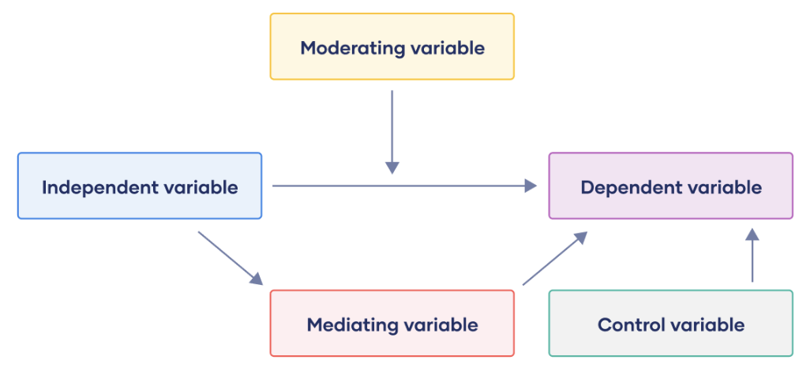

**Figure 1.** Review of conceptual framework.

**3. Methods** (Font: Palatino Linotype, Size: 10, bold)

The Methods section should provide a clear and detailed description of how the research was conducted to enable replication. Authors should begin by explaining the research design, specifying whether the study is quantitative, qualitative, or mixed methods, and justify why this design is suitable for addressing the research objectives. Next, describe the population and sample, including the target population, the sampling technique used, and the sample size, while stating any inclusion or exclusion criteria relevant to the study.

Authors should then describe the data collection methods, explaining the instruments or tools used such as questionnaires or interview guides, along with their validity and reliability where appropriate. The procedure should be outlined clearly, describing the steps taken during data collection and mentioning any ethical considerations and approvals obtained to ensure research integrity. Finally, the data analysis approach should be explained, detailing the statistical or thematic analysis techniques used to interpret the data. Ensure clarity, conciseness, and consistency in this section. (Font: Palatino Linotype, Size: 10)

**4. Results**

The Results section should present the findings of the study clearly and objectively without interpretation. Authors should begin by providing a brief overview of the data analysis outcomes, followed by detailed reporting of each result in alignment with the research objectives and hypotheses. Present descriptive statistics such as means, standard deviations, or frequencies where relevant to summarize the data. For inferential statistics, report the statistical tests used, the values obtained, degrees of freedom, significance levels, and effect sizes if applicable.

Results should be organized logically, often following the order of the hypotheses or research questions. Use tables and figures to support and illustrate the findings clearly, ensuring they are numbered sequentially and referenced appropriately within the text. Avoid repeating all data in text and tables; summarize key points in text while detailed values remain in tables. Maintain an academic tone, clarity, and consistency in reporting throughout this section without providing interpretation or discussion of the results. (Font: Palatino Linotype, Size: 10)

**5. Discussion**

The Discussion section should interpret and explain the results in the context of the research objectives and existing literature. Authors should begin by summarizing the key findings of the study, highlighting how these results address the research questions or hypotheses. Discuss the implications of the findings, explaining their significance for theory, practice, and future research. Authors should compare the results with previous studies, identifying similarities, differences, and possible reasons for any inconsistencies.

Additionally, discuss the strengths of the study and acknowledge its limitations, explaining how these limitations may have affected the results or their generalizability. It is important to avoid merely repeating the results; instead, provide a critical and analytical interpretation that adds value to the findings. Conclude the discussion by summarizing the main insights and suggesting practical recommendations or areas for further research. Maintain clarity, coherence, and academic tone throughout this section. (Font: Palatino Linotype, Size: 10)

**6. Conclusions**

The Conclusion section should provide a concise summary of the main findings and their implications. Authors should begin by restating the purpose of the study and briefly summarizing the key results in relation to the research objectives. Highlight the significance of these findings for theory, practice, or policy, emphasizing their contribution to the existing body of knowledge. Avoid introducing any new data or detailed interpretations in this section.

Authors may also include practical recommendations based on the study outcomes, if applicable, and suggest specific areas for future research to address limitations or unexplored aspects identified in the study. The conclusion should be written clearly and succinctly, leaving readers with a strong understanding of the study’s relevance and value. Maintain an academic and objective tone, ensuring consistency with the rest of the manuscript and providing a strong closing for the paper. (Font: Palatino Linotype, Size: 10)

**Author Contributions:** Conceptualization, Full Name of Author 1, Full Name of Author 2; methodology, Full Name of Author 1, Full Name of Author 2; software, Full Name of Author 1, Full Name of Author 2; formal analysis, Full Name of Author 1, Full Name of Author 2; supervision, Full Name of Author 1, Full Name of Author 2; writing—original draft, Full Name of Author 1, Full Name of Author 2; Writing—Review & Editing: Full Name of Author 1, Full Name of Author 2; All authors have read and agreed to the published version of the manuscript.

**Funding:** No external funding was received for this research.

**Institutional Review Board Statement:** Not applicable.

**Informed Consent Statement:** Not applicable.

**Data Availability Statement:** Data are available upon request from the authors.

**Conflicts of Interest:** The authors declare no conflicts of interest.

**References**

Reference style will be APA 7th edition style. (Font: Palatino Linotype, Size: 10)

Journal Article

Smith, J. A., & Lee, R. T. (2022). Innovation strategies and performance outcomes in manufacturing firms. Journal of Business Research, 135, 45–56. <https://doi.org/10.1016/j.jbusres.2021.12.015>

Book

Brown, L. M. (2020). Strategic management in global organizations. Oxford University Press.

Book Chapter

Davis, K. J. (2019). Leadership development in modern organizations. In T. R. Wilson & P. S. Harris (Eds.), Organizational behavior: Theory and practice (pp. 215–230). Sage Publications.

Conference Proceedings Paper

Chen, Y., & Kumar, S. (2021). Exploring supply chain resilience under COVID-19 disruptions. In Proceedings of the 2021 International Conference on Operations Management (pp. 102–110). IEEE. https://doi.org/10.1109/ICOME.2021.00020

**Disclaimer/Publisher’s Note:** The views, interpretations, and information presented in all publications are solely those of the respective author(s) and contributor(s) and do not necessarily reflect those of Meta Open Sciences and/or the editor(s). Meta Open Sciences and/or the editor(s) accept no responsibility for any harm, loss, or damage to individuals or property that may arise from the application of ideas, methods, instructions, or products mentioned within the content.